**Scenario 1:**

**When a single and correct json is copied to source directory for the 1st time.**

Before:

Source and Target directory in Container A are empty:

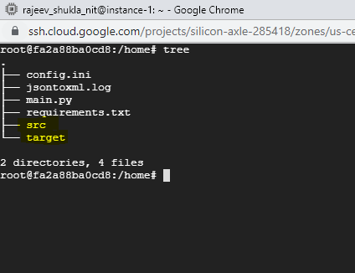

FTP server has no file:

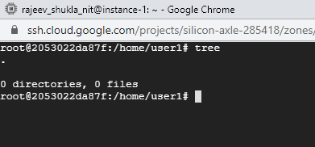

Execution:

Copy a correct json file to ./home/src directory of container A using command $ sudo docker cp testdata/emp1.json jsontoxmlconvertor:./home/src

./testdata/emp1.json

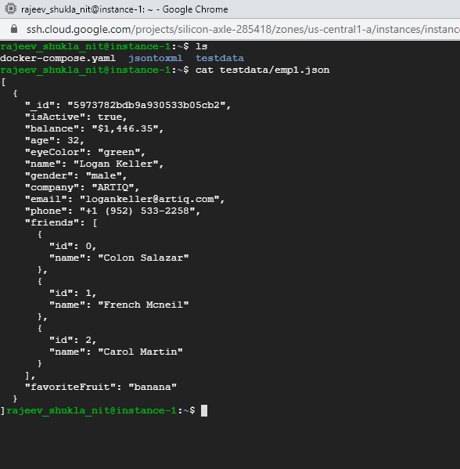

Copied file from host to container A:



After:

Json file should be converted to xml and remotely transferred to container B. Which stores it as per the date (D20210911).

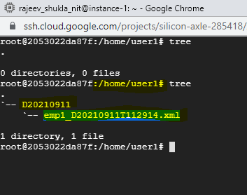

Input file should be archived under source directory and xml generated should be archived under target folder.

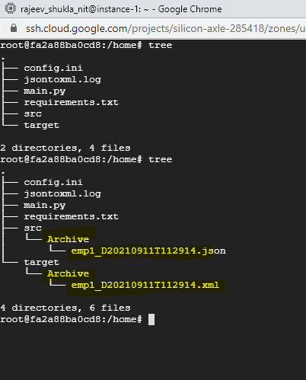

Verify logs generated in log file

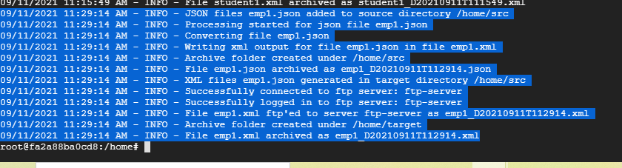

**Scenario 2:**

**When a single and incorrect json is copied to source directory.**

Input file:

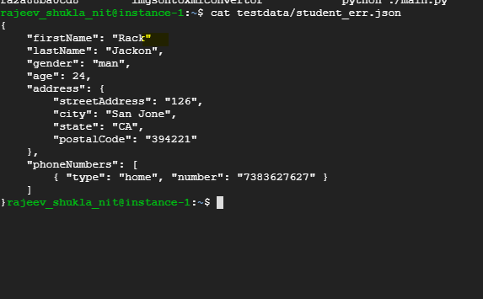

Execution:

Copy the json file to ./home/src



After:

File with error should be processed and converted to xml.

Should be archived under source folder

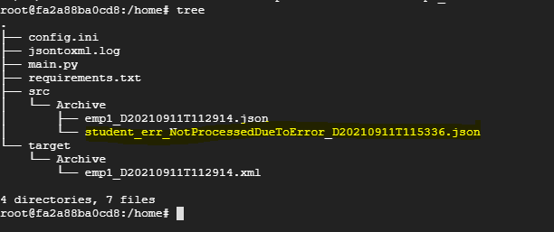

No files should be transferred to container B.

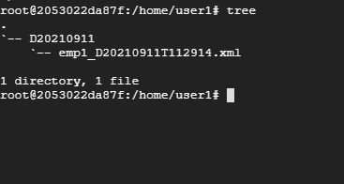

Verify the logs:

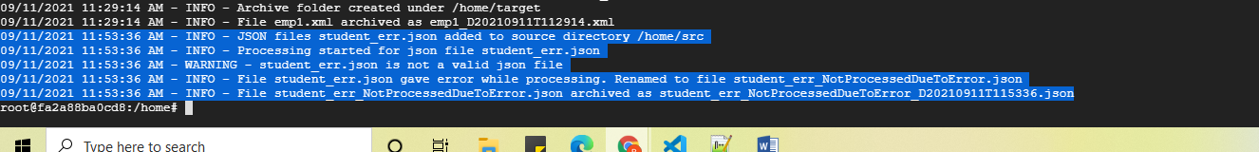

**Scenario 3:**

**When a non-json is copied to source directory.**

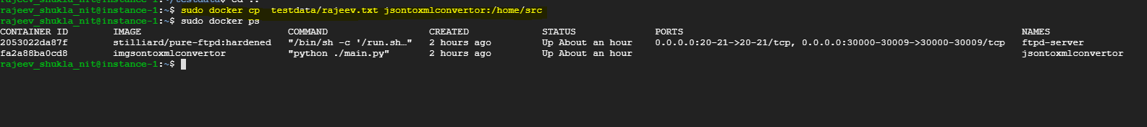

After:

File should be copied under source but not processed.

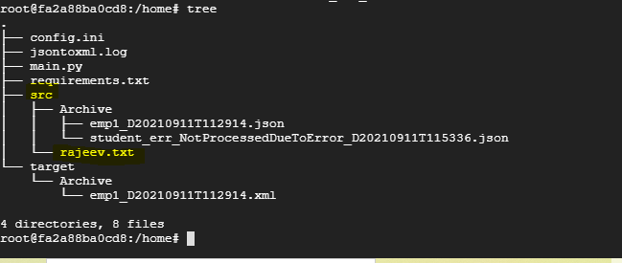

No file transferred to Container B



Verify logs. No Processing done

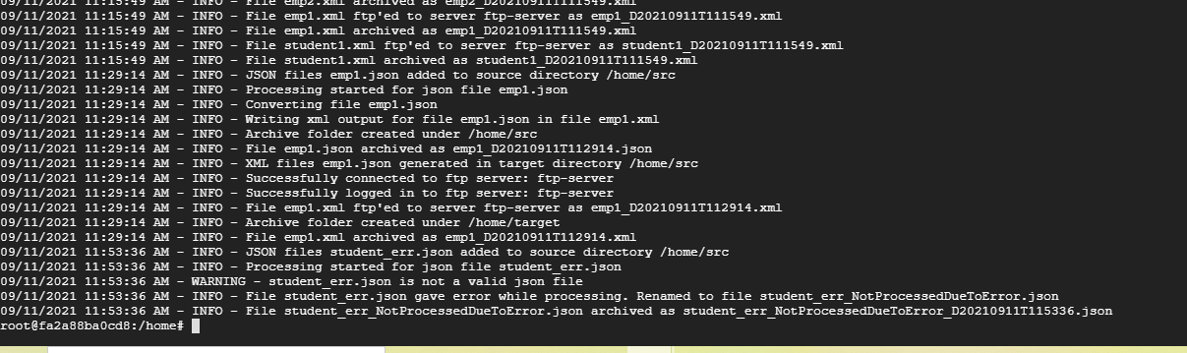

**Scenario 4:**

**When multiple files are copied (error, non-json, same file as before).**



After:

All json file should be processed. Once with error should be archived with error tagged.

All non-json files should not be processed.

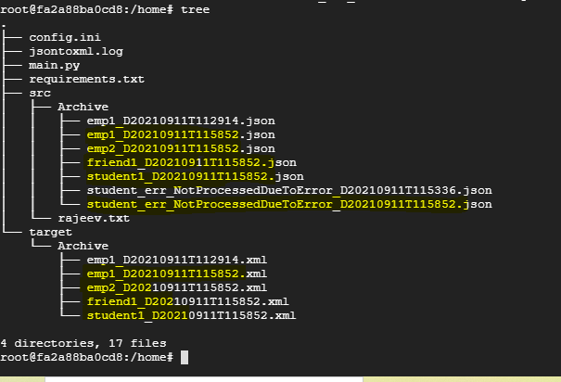

All correctly converted xml files should be transferred to container B, with correct timestamp. Should not override the previous files.

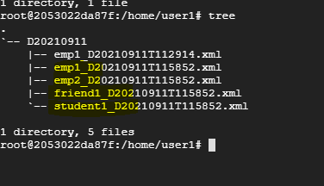

**Scenario 5:**

**When a file is copied on different system date,**



A new directory with Current system date should be created and the xml file should be copied under it.

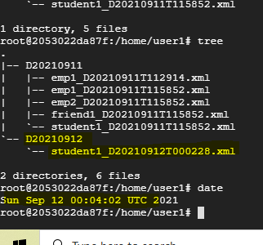

The input file and xml generated should be archived with current system timestamp

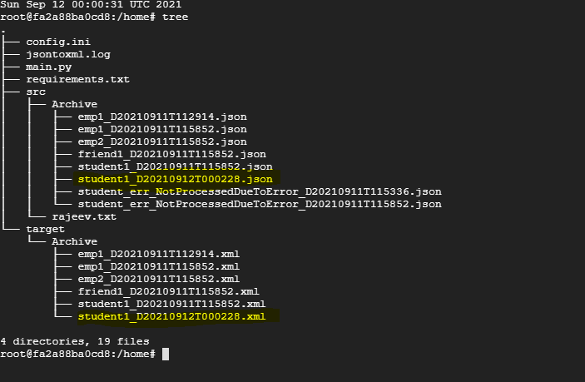

**Scenario 6:**

**When the ftp server is down and file is copied to jsontoxmlconvertor.**

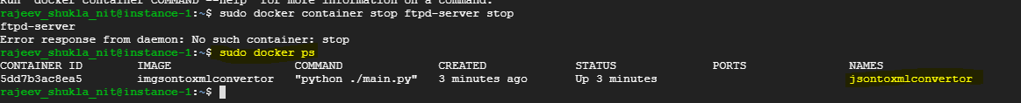

**Copy file to jsontoxmlconvertor**



**Python job should be still running and retry every 10 seconds now.**

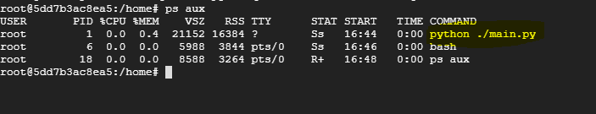

**Json file should be converted to xml but should not be transferred.**

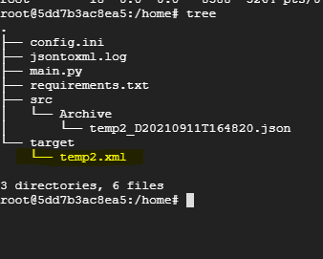

**Logs should be updates:**

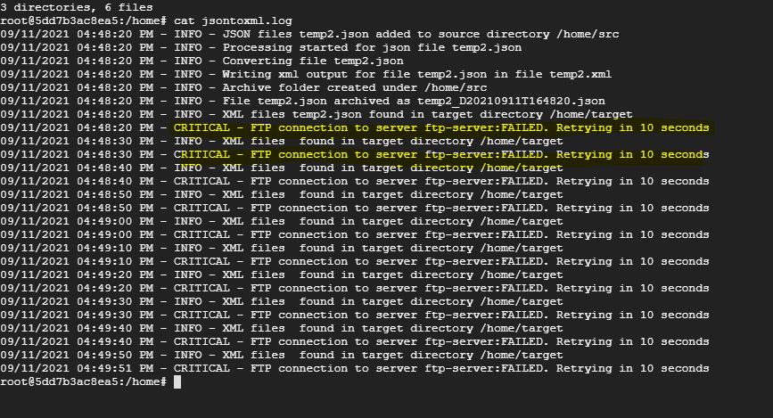

**Now start the container again.**



**Pending file should be transferred and then archived.**

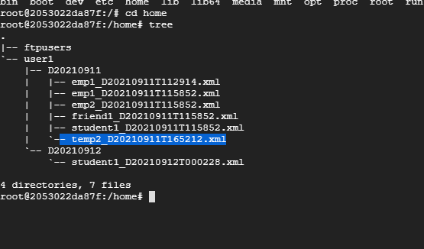

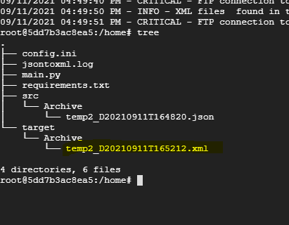

**Scenario 7:**

**When the wrong credentials are given for ftp server.**

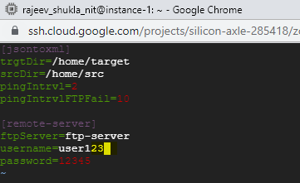

Docker containers running:



Copy file to src:



The python job should fail and docker container stops:



Verify the error in the logs:

